**Project report**

**on Local-Ket (shopping cum helping website)**

Submitted in partial fulfillment of the requirements for the award of degree of

**BACHELOR OF ENGINEERING**

**IN**

**COMPUTER SCIENCE & ENGINEERING**



**Submitted to: Submitted By:**

**Raman Chadha sir Shivani Singh**

**19BCS2546**

**CSE 11B**

**Mentor signature**

**(Name & E-code)**

**DEPARTMENT OF COMPUTER SCIENCE & ENGINEERING**

**Chandigarh University, Gharuan**

**July-December 2021**

**CERTIFICATE**

This is to certify that the work embodied in this Project Report entitled **“Local-Ket (shopping cum helping website)”** being submitted by **“Shivani Singh” -**

UID **“19BCS2546” ,** 5th Semester for partial fulfilment of the requirement for the degree of **“ Bachelor of Engineering in Computer Science & Engineering ”** discipline in “ **Chandigarh University** ” during the academic session Jan-Jun 2021 is a record of bonafide piece of work, carried out by student under my supervision and guidance in the **“ Department of Computer Science & Engineering ”, Chandigarh University.**

**APPROVED & GUIDED BY:** Dr. Raman Chadha

**DECLARATION**

I, student of **Bachelor of Engineering** in **Computer Science & Engineering, 5 th  Semester** , **session: July - December 2021, Chandigarh University,** hereby declare that the work presented in this Project Report entitled **“Local-Ket (shopping cum helping website)”** is the outcome of my own work, is bonafide and correct to the best of my knowledge and this work has been carried out taking care of Engineering Ethics. The work presented does not infringe any patented work and has not been submitted to any other university or anywhere else for the award of any degree or any professional diploma .

**Student details and Signature:**

**Team Member 1: Shivani Singh(19BCS2546) **

**APPROVED & GUIDED BY:**

**Dr. Raman Chadha**

To our parents, teachers and all the well-wishers out there . .

## Abstract

Local-Ket (shopping cum helping website) which is short form of Local Market is a website where people can buy things of their choice from their own locality and market. It will be like a local website of a city where all the products of the market like clothes, grocery items, dairy products etc. will be available just like the market. It also aims to promote the local traders and manufacturers of the locality. Like in pandemic we saw that how local traders business closed due to lockdown and all. How they were suffering and didn’t had any earning for their living. So this website will aim to provide jobs to them. The local trader like handicrafts maker, shopkeeper and many more can sell their products here and promote their products. The highlights of the website are: sell your product in one tap, free and safe delivery, handicrafts and natural products, job security, all the needed household number, no worry about losing jobs, minimum delivery charge. There will be different sections like shop by categories which include kids section, women section, men section, grocery/dairy products and especially handicrafts section to promote the local culture and architect i.e. be vocal about local.

## Table of Contents

Introduction 1

Menu 2

Feasibility study 7.

Need of the project 7.

Significance of the project 8.

Methodology/planning of work 8.

Innovations in the project 9.

Specifications 9.

Project Design 10.

1 level DFD: 11.

Sequence diagram 12.

Use case diagram 13.

Conclusion 14.

Bibliography 15.

## Table of Figures

Menu..................................................................................................................................2

Figure 1.1:

Home page view..................................................................................................2

Figure 1.2:

Options available in Local-Ket seen from android.............................................................3

Figure 1.3:

Home page view seen from pc..............................................................................................4

Figure 1.4:

High lights of Local Ket.................................................................................................4

Figure 1.5:

High lights of Local Ket........................................................ ......................................5

Figure 1.6:

Shop by categories.................................................................................................................5

Figure 1.7:

Helpline numbers............................................................................................................6

Figure 1.8:

Contact Us.........................................................................................................................6

Figure 1.9:

Footer section........................................................................................................................7

Figure 2.1:

1 Level DFD............................................................................................................................11

Figure 2.2: Sequence diagram................................................................................................12

Figure 2.3:

Use case diagram.......................................................... ...........................................................13

## Project

## Description

# Introduction

# Local-Ket (shopping cum helping website) which is short form of Local Market is a website where people can buy things of their choice from their own locality and market. It will be like a local website of a city where all the products of the market like clothes, grocery items, dairy products etc. will be available just like the market. It also aims to promote the local traders and manufacturers of the locality. Like in pandemic we saw that how local traders business closed due to lockdown and all. How they were suffering and didn’t had any earning for their living. So this website will aim to provide jobs to them. The local trader like handicrafts maker, shopkeeper and many more can sell their products here and promote their products. The highlights of the website are: sell your product in one tap, free and safe delivery, handicrafts and natural products, job security, all the needed household number, no worry about losing jobs, minimum delivery charge. There will be different sections like shop by categories which include kids section, women section, men section, grocery/dairy products and especially handicrafts section to promote the local culture and architect i.e. be vocal about local. There will be again a different section where all the needed household numbers will be available like of washer-man, mason, laborer, painter, electrician, plumber, mechanic etc. there number and working address will be displayed there by which any people can contact them and take help from them. Delivery of the desired products will be done in 3-4 working days, and 24/7 support system. There will be 7 days return policy which includes faster return and repayment policy. Minimum delivery charge will be applicable to the products. There will also be a small donation section where people if want may donate according to their capacity. This is only a font end design of the project. In coming months and year, I will also develop back end part.

The technology used in this project are HTML5, CSS and JavaScript. Functionality of HTML and JavaScript are used here very much like slider, box model etc.

[1]

**Menu**

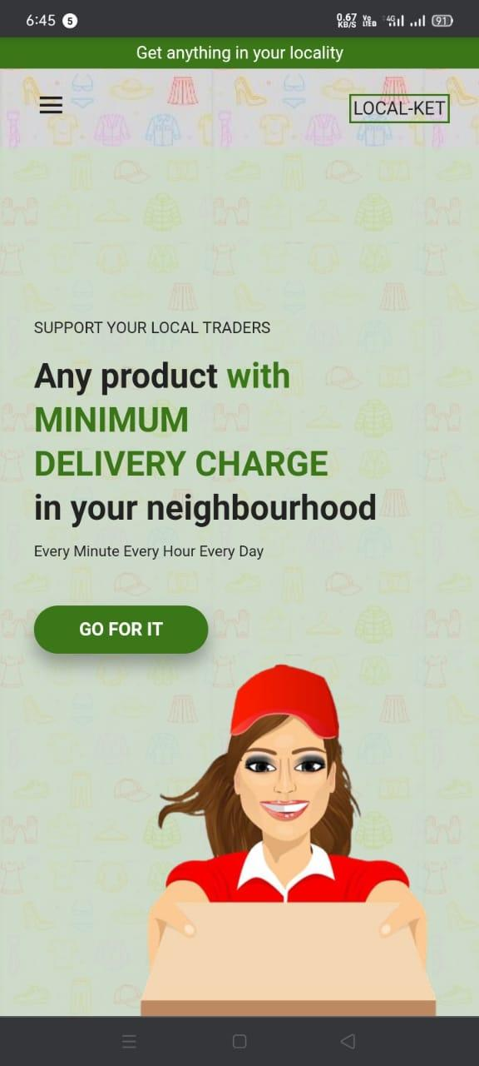

Fig. 1.1 (home page view of Local-Ket seen from android)

Above is the picture of the home page of the website. How will it look when seen from any android phones.

[2]

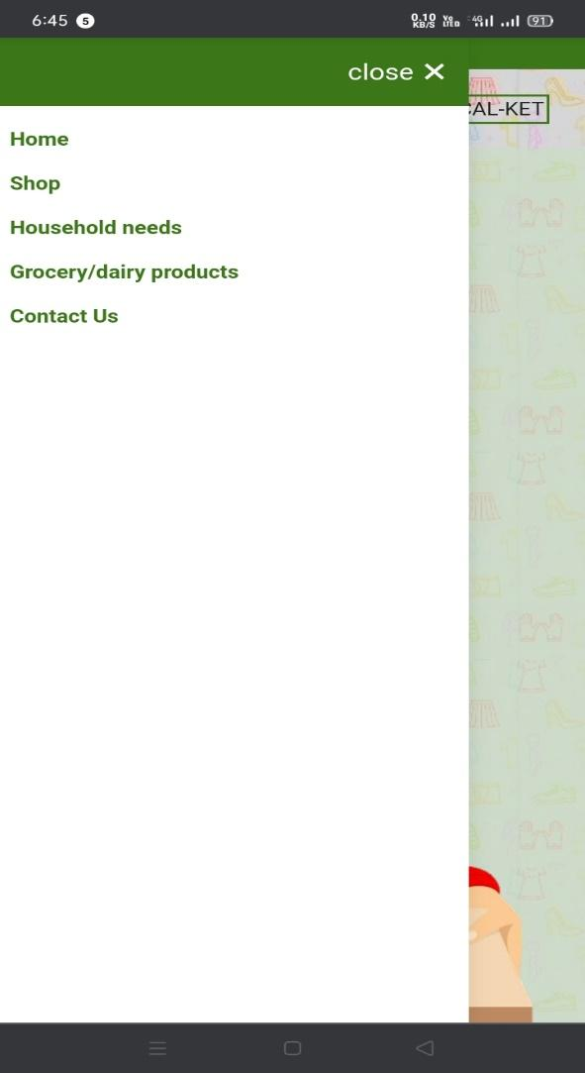

Fig. 1.2 (options available in Local-Ket seen from android)

Above is the picture of all the categories available in the website (it may change according to time and progress).

[3]

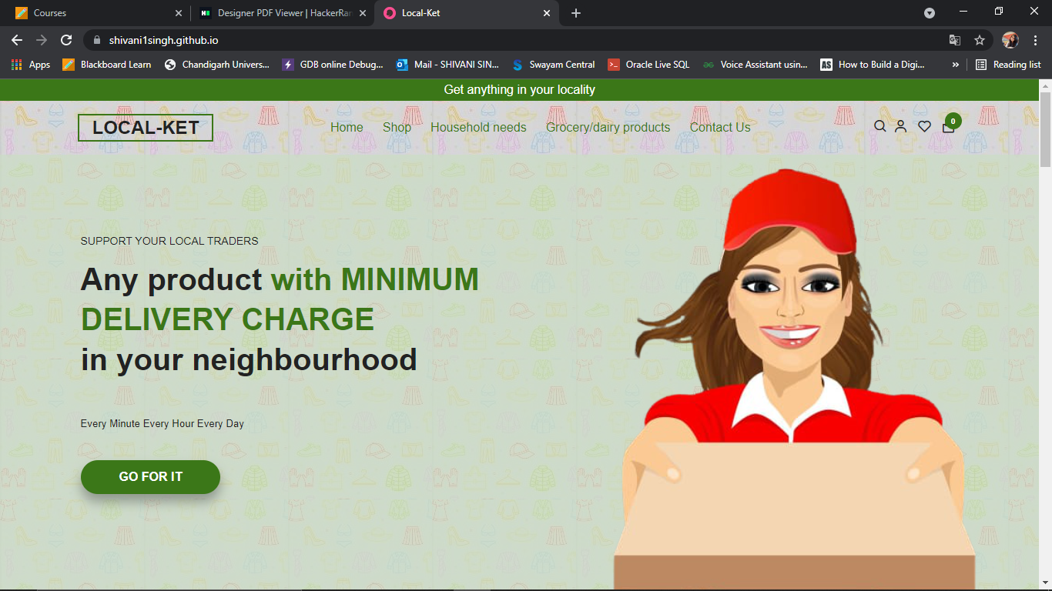

Fig. 1.3 (home page view seen from PC)

Above is the picture of home page seen from PC and laptop. The website is fully responsive. It shows the options which we may avail like shop, household needs, and grocery/dairy products and contact us.

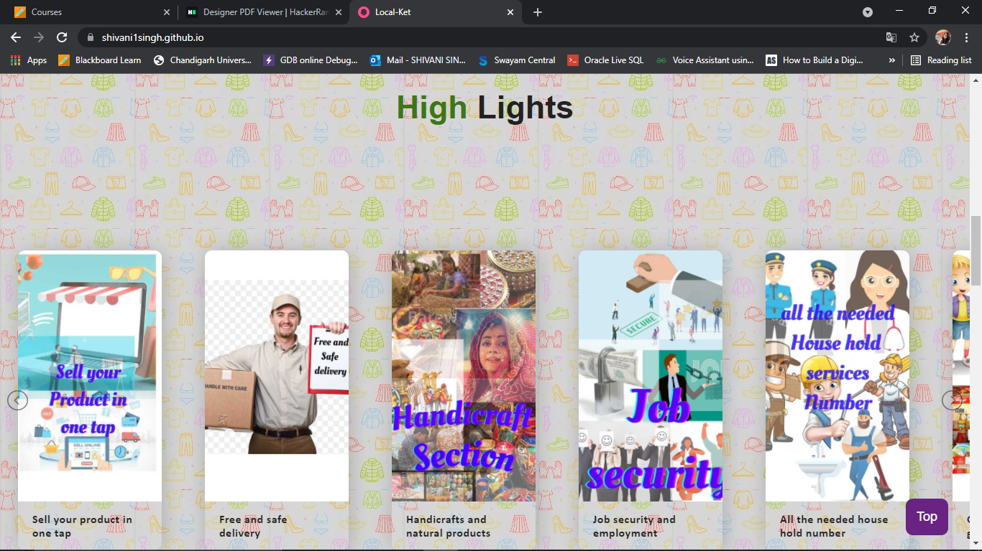

Fig. 1.4 (high lights of Local-Ket)

It shows the high lights of the website. What the website famous is for and why we should use it in the first place. Why this website is helpful for the local customers as well as the local traders and small scale industrialists. It depicts all the advantages present.

[4]

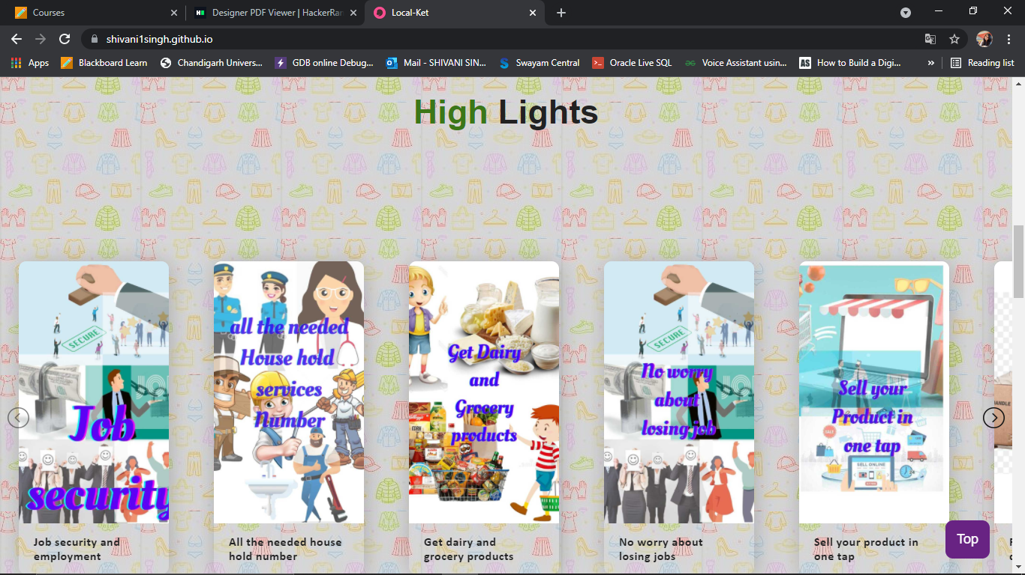

Fig. 1.5 (high lights of Local-Ket)

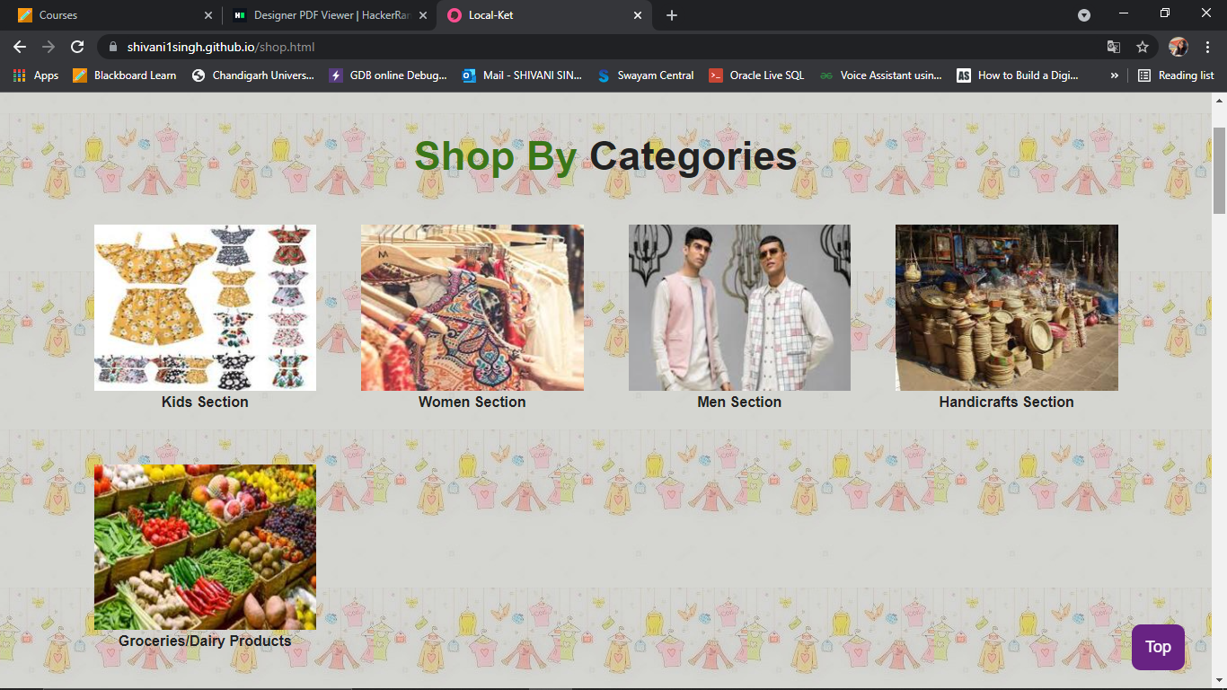

Fig. 1.6 (shop by categories)

It is showing the shopping categories present in the website like groceries/dairy products, clothing section such as kids section, men section, women section, and handicrafts section. User can select from the above options and go to that section of the page.

[5]

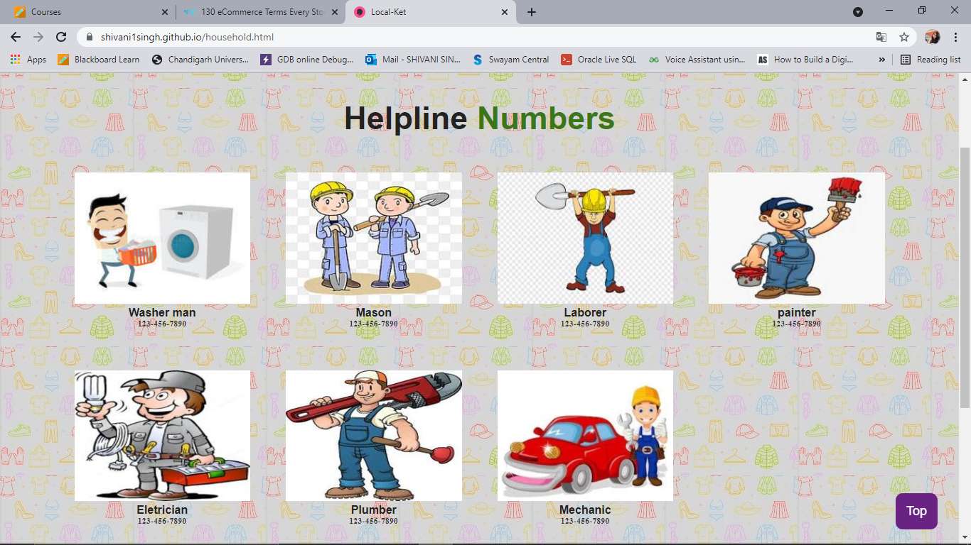

Fig. 1.7 (Helpline numbers)

It is showing the helpline numbers present in the website. User can directly access this and call for help according to their needs.

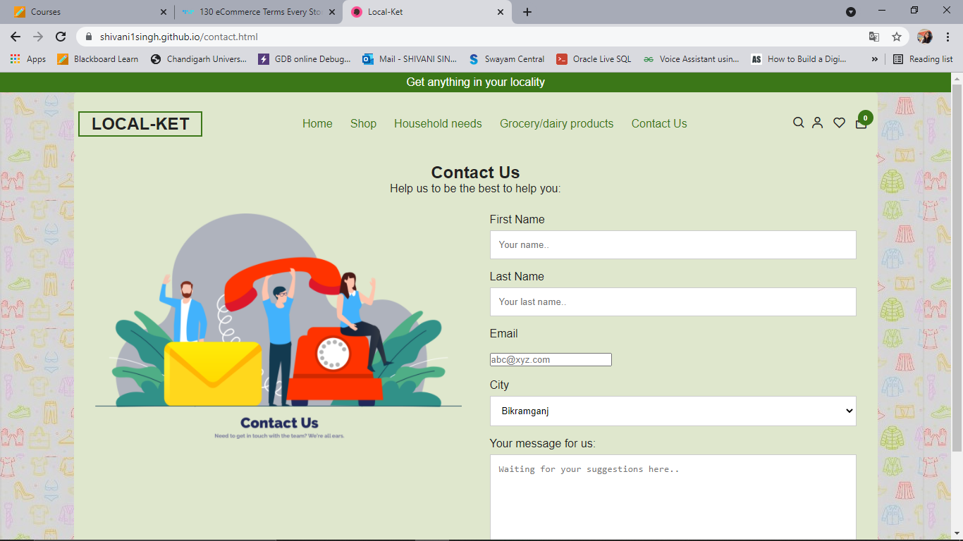

Fig. 1.8 (Contact Us)

It is showing the contact us page of the website. User can write their queries here.

[6]

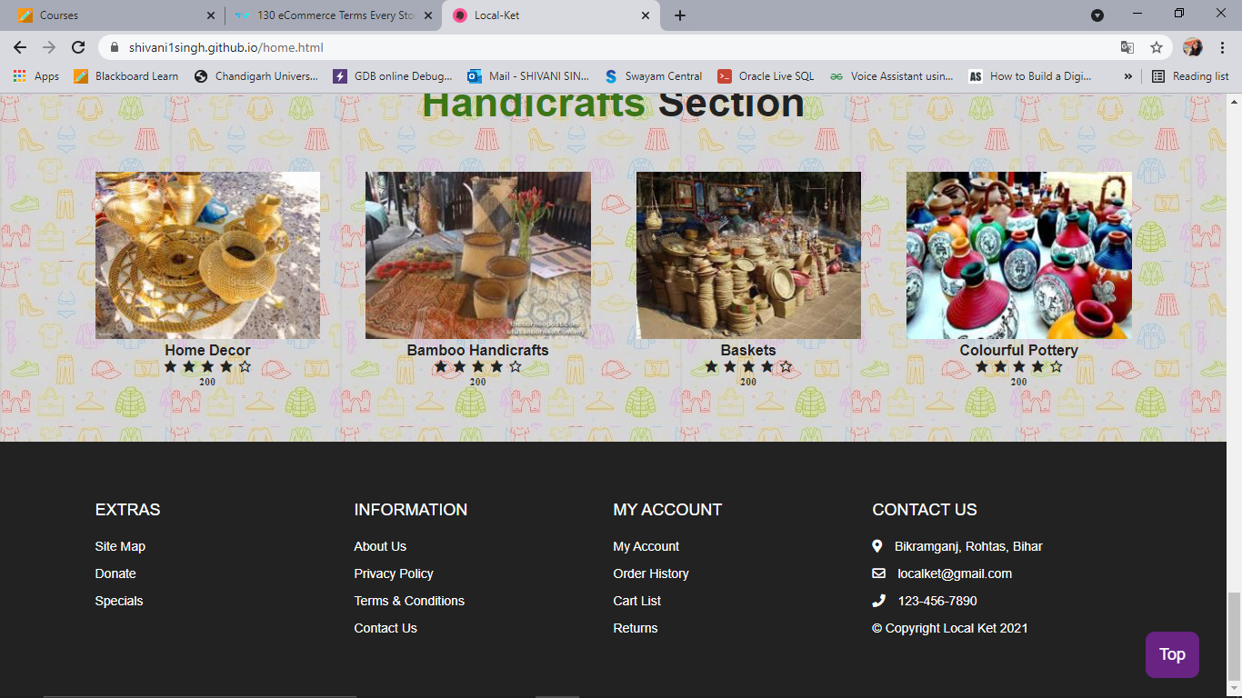

Fig. 1.9 (Footer section)

It is showing the footer section of the website. It contains all the important links to the other pages.

**Feasibility study**

As we know feasibility study determines whether the project[is likely to succeed](https://www.pmi.org/learning/library/seven-causes-project-failure-initiate-recovery-7195) in the first place. Local-Ket is a project which is feasible for everyone and it can be used by any people of any locality. He/she needs to know only how to click clear picture of any product and upload it on the website. As I am making this website so that the traders of any locality does not suffer any loss during hard times like this. And also with the help of this website people of a locality will be able to order online all the products they need and with the minimum delivery charge. As we see that when we order from Amazon or Flip kart, the product is of Rs. 40 and delivery charge if Rs. 60. This is not feasible for any customer. So in Local-Ket, there will be minimum delivery charge applicable. As this website is promoting vocal for local this will promote the small scale industries also. As this website does not require any prior knowledge of anything, nor money, one only needs to go on the website and order the products of their choice and buy it and for the traders they only need to upload their products for the sale. So this website is feasible for everyone and profitable as well.

**Need of the project**

This project will help the customers to get the products of their market in just a click. They will be able to visit each and every shop of their market online and do shopping. They will be able to also shop grocery and dairy products from there. They will be able to get the numbers of all the needed household helpers like electrician, plumber, washer-man etc. at one place. They don’t need to directly visit their shop for the repairing or anything. They will be able to call them home for the services and pay them their only. As for the shopkeepers, traders, small scale industrialists, they will be directly able to sale their products online. They will be given the option to sale their products there only.

[7]

And also there are many handicrafts products many handicrafts products which can also be sold like handmade duppatta, baskets, carpets, toys, etc. This will also promote their makers and they will also be given credits for their hard work and their products will be seen by everyone.

**Significance of the project**

Local-Ket (shopping cum helping website) is a website by which people can buy their market products online. This is feasible for everyone and can be used by anyone. It will also give the rights to shopkeepers to sale their products there only. It also includes the numbers of all needed household helpers.

This front end of this website is designed only in HTML, CSS and JavaScript language.

**Methodology/planning of work**

First of all, we need to understand the concept behind the shopping website. To achieve the objective of the project we need to install all the extensions, google languages, js modules etc. needed in the project. And divide all the work in the priority basis to work accordingly and efficiently to complete the modules on time.

The methodology of this project is following:

* Understand the concept of existing shopping websites like Amazon, Flip kart, EBay etc. and how their shopping algorithm work.
* Write the project proposal and synopsis of the project.
* Study all the attributes, classes, slider concept, and css properly.
* Install all the extensions needed to run the code like Live server extension, html extension etc.
* Establish work environment for the language.
* Create the code for the project of the work and run it on VS code.
* See if the code has any errors and it’s according to your requirement or not.
* Run all the code with all the HTML, CSS and JavaScript files needed.
* Write the summary of the project.

[8]

**Innovations in Project**

* Shopping website for a locality.
* People are able to get the desired products in just one click.
* Minimum delivery charge applicable.
* Delivery of products in 2-3 working days.
* Promote vocal for local.
* People can also denote money for the one in need.
* Traders can be able to sale their products online.
* All the needed household numbers at one place.
* Can use it anytime, anywhere.

**Specifications**

* Software requirements -
* OS ( Windows or Linux)
* Visual Studio code (all needed extensions are here only just need to download it)
* Hardware requirements -
* RAM: 512 MB
* Disk Space: 1gb
* CPU: Pentium 2 processor
* Processor Speed: 1ghz
* Platform: 32-bit / 64-bit machine
* Laptop or personal computer

[9]

**Project design**

First of all, we need to understand the concept behind the shopping website. To achieve the objective of the project we need to install all the extensions, google fonts, JS modules etc. needed in the project. And divide all the work in the priority basis to work accordingly and efficiently to complete the modules on time.

The methodology of this project is following:

* Understand the concept of existing shopping websites like Amazon, Flip kart, EBay etc. and how their shopping algorithm work.
* Write the project proposal and synopsis of the project.
* Study all the attributes, classes, slider concept, and css properly.
* Install all the extensions needed to run the code like Live server extension, html extension etc.
* Establish work environment for the language.
* Create the code for the project of the work and run it on VS code.
* See if the code has any errors and it’s according to your requirement or not.
* Run all the code with all the HTML, CSS and JavaScript files needed.
* Write the summary of the project.

[10]

**1-level DFD**

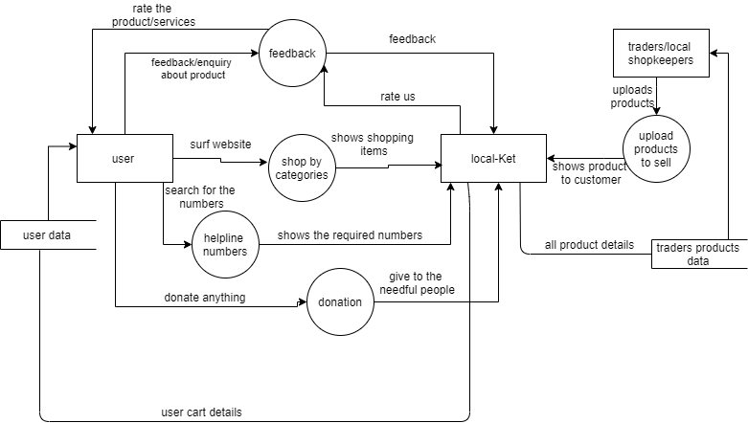

Fig: 2.1 (1-level DFD)

[11]

**Sequence diagram**

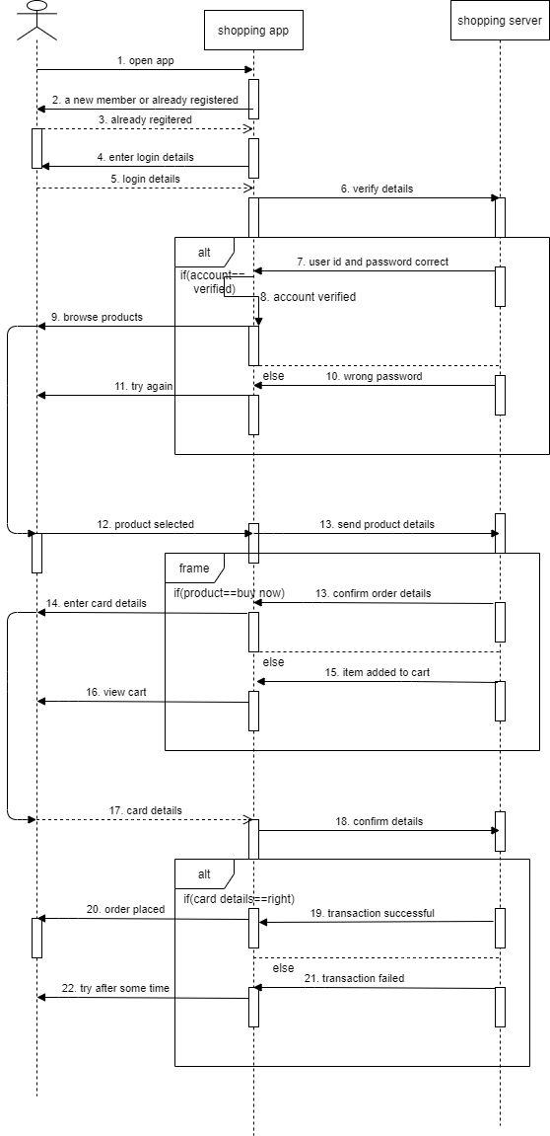

Fig: 2.2 (Sequence diagram)

[12]

**Use case diagram**

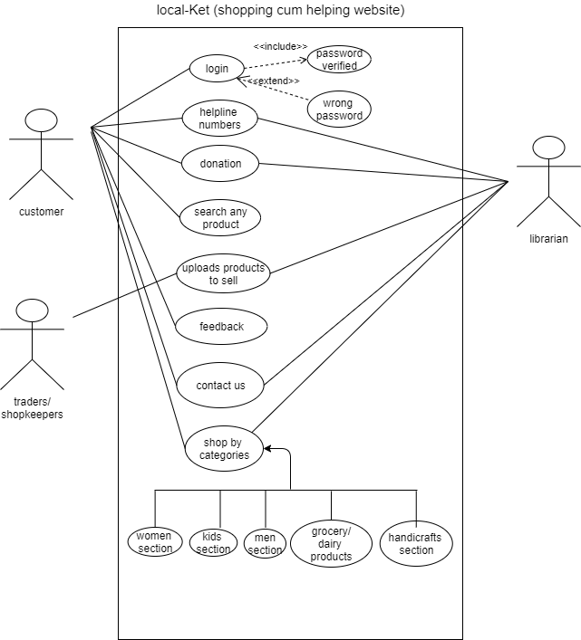

Fig. 2.3 (Use Case Diagram)

[13]

**Conclusion**

The conclusion of this project is that Local – ket is a shopping cum helping website which will help the people of a locality to do sell their products online and give customer the privilege to buy anything from their locality n just a click. The local trader like handicrafts maker, shopkeeper and many more can sell their products here and promote their products. The highlights of the website are: sell your product in one tap, free and safe delivery, handicrafts and natural products, job security, all the needed household number, no worry about losing jobs, minimum delivery charge. Minimum delivery charges will be applicable to all the products there. Delivery of the desired products will be done in 3-4 working days, and 24/7 support system. There will be 7 days return policy which includes faster return and repayment policy. With the help of this website, people can also donate the money for those who are in needs for that. There will be a separate page for the helpline workers. And people can directly fetch their contact from the website and book appointment. Most important it promotes **vocal for local** and can use it anytime, anywhere.

[14]

# Bibliography

[1] Mingzhen Zhang, Research on Interface Design of Smartphone Application Based on User Experience [D], Jiangnan University, 2011

[2] Le Shen, Research on E-commerce Website Design Based on User Experience——Taking Online Digital Printing as an Example[D], East China University of Science and Technology, 2013

[3] Jesse James Garrett, Elements of User Experience, Mechanical Industry Press, [D], 2011:52-56

[4] Lu Du, Xia Zhong, Research on UGC type models of socialized e-commerce websites based on user experience[J], Design, 2014(4), 82-84

[5] DIANA DB. Agile User Experience Design [M]. Beijing: Machinery Industry Press, 20

[6] Patricia L. Roland H .Trust worthiness in e-commerce 2004.

[7] Talking about the elements of user experience:An interview with Jesse James Garrett.2006.http://webword.com/interviews/king.html.

[8] Efraim Turban, Jae Lee, David King,et al.Electronic Commerce: a Managerial Perspective[M]. USA:Prentice-Hall,Inc,2002:84115

[9] Ranganathan C, Shobha Ganapathy. Key Dimensions of Business-to-consumer WebSites[ J].Information& Management,2002,39(6):457465

[15]